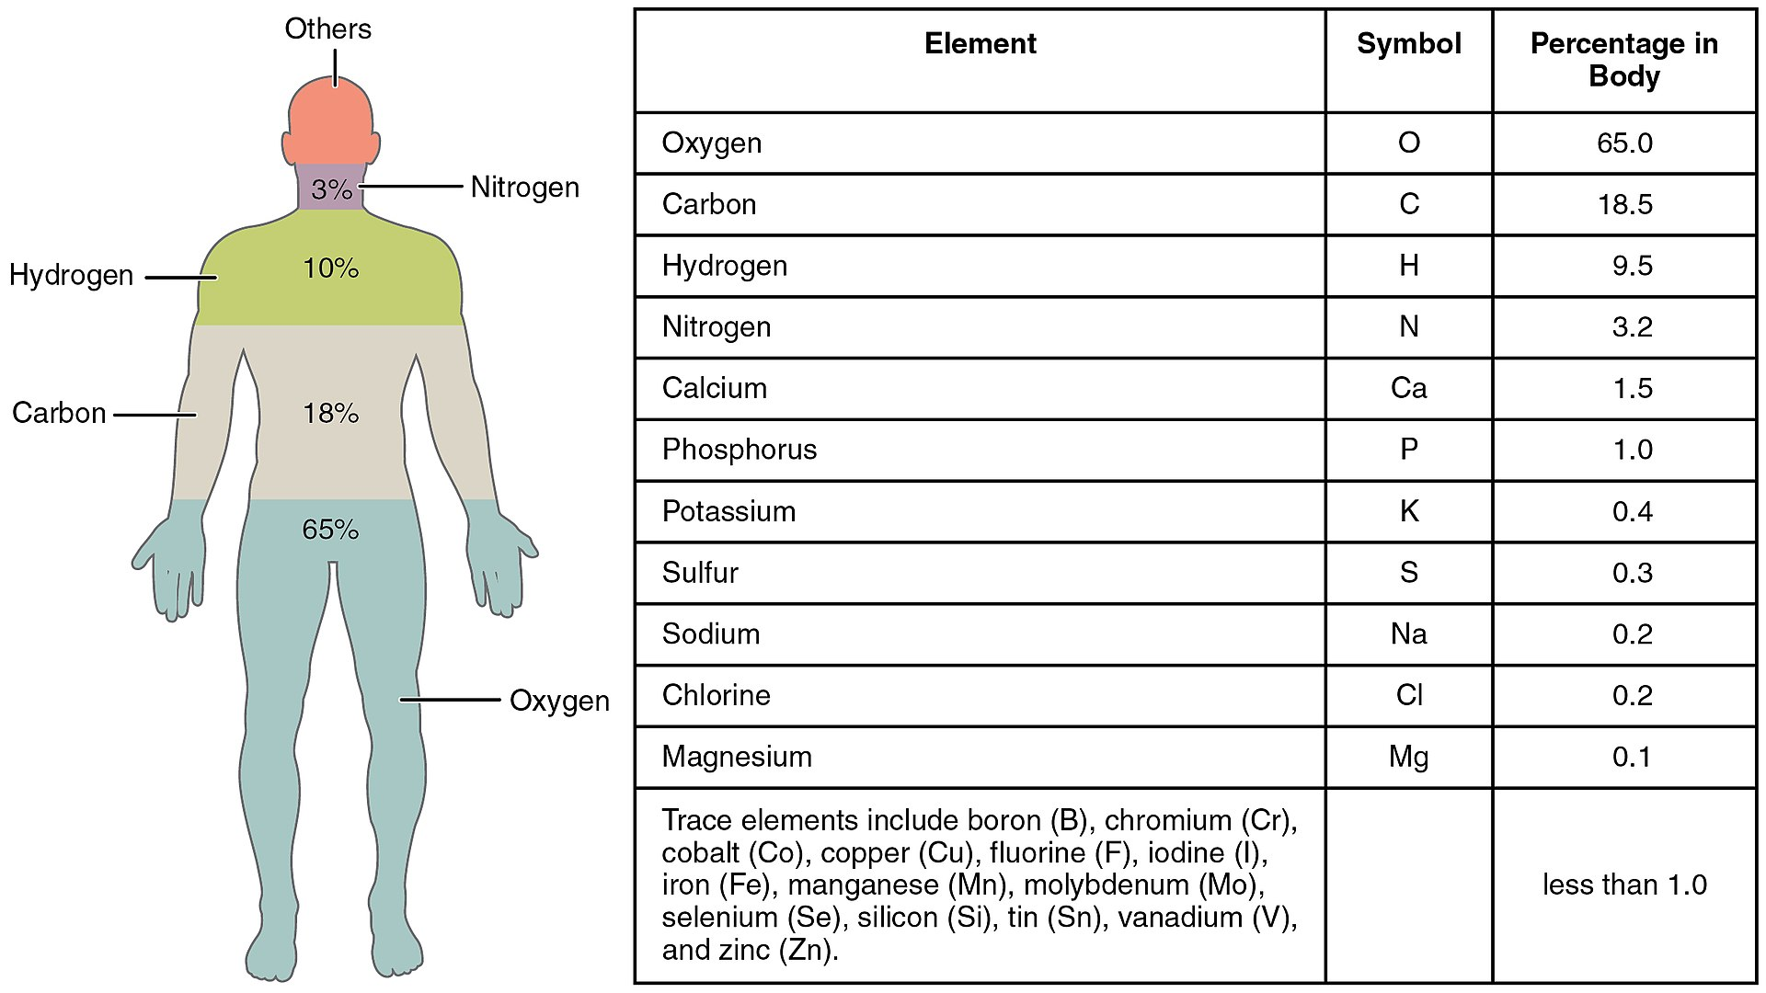METALS in Your Body

3. Look at the diagram. What is the most common element in your

body?__________________

Why is this element so common? (Hint, your body is mostly water, H2O.)___________________________________________________

________________________________________________________

2. What do you think would happen if you ate some

metal?____________________________________

­­­­­­­­­­­­­­­­___________________________________________

___________________________________________

DO NOT EAT METALS !!! Your stomach cannot normally digest them.

1. Name some objects that you have touched today

that are made of metal._______________________

­­­­­­­­­­­­­­­­___________________________________________

___________________________________________

___________________________________________

4. The elements listed below are all found in your body. Which elements are METALS?

|  |  |  |  |
| --- | --- | --- | --- |
| oxygen | nitrogen | iron | chlorine |
| carbon | calcium | sodium | copper |
| hydrogen | magnesium | potassium | zinc |

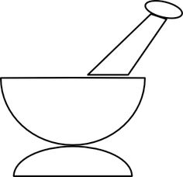

6. Why we need metals in our diet.

|  |  |  |  |
| --- | --- | --- | --- |
| **Symbol** | **Name** | **Function in your body** | **Foods containing this metal** |
| ______ | calcium | Strong bones and teeth | _________________________________ |
| ______ | magnesium | Steady heart beat | _________________________________ |
| ______ | iron | Important in red blood cells, which carry oxygen to every part of your body | _________________________________ |
| ______ | sodium | Keeps the electrical signals from your brain to your muscles running, prevents cramps | _________________________________ |
| ______ | potassium | Muscle contractions, prevents muscle cramps | _________________________________ |
| ______ | zinc | Helps your body fight bacteria and virus, immune system | _________________________________ |

5. Description of most metals:

|  |
| --- |
| **Description of most metals:** |
| * Most metals are _______________, conduct ____________ and electricity | |
| * Some metals explode when they touch ____________ | |
| * Some metals are magnetic |
|  |
|  |
|  |
|  |

mortar & pestle- used to crush or grind into very small pieces

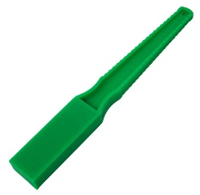

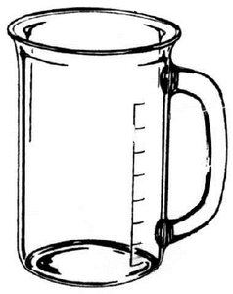

magnetic wand

beaker