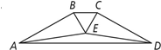
Given: ∠EAD ≅ ∠EDA, ΔBEC is equilateral.
∠ABE and ∠DCE are right ∠s.

Prove: ΔABE ≅ ΔDCE

Statements Reasons

