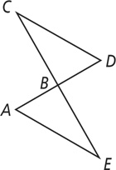
Given:$∠ABE≅∠DBC$
$$\overline{CD}≅\overline{AE}$$
$∠ABE and ∠DBC$ are supplementary.
B is the midpoint of $\overline{AD}$

Prove: ΔABE ≅ ΔDBC

Reasons
Statements

